ASSIGNMENT 4
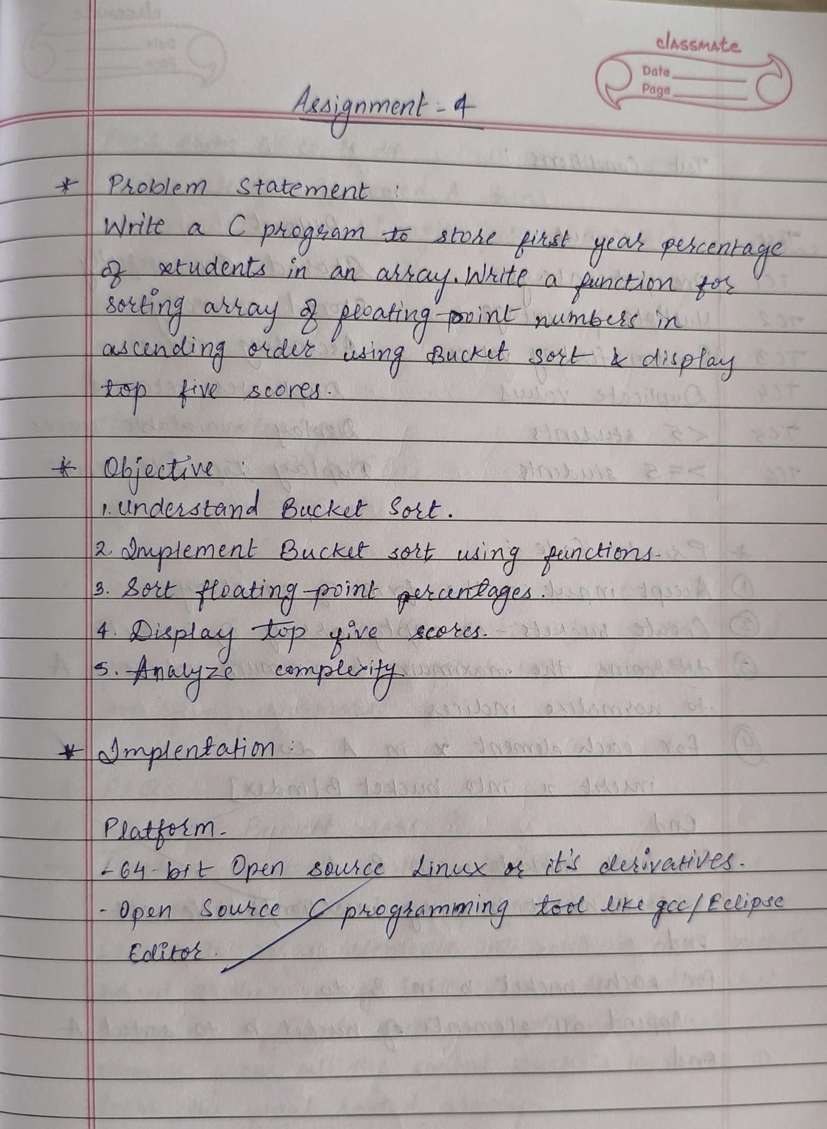
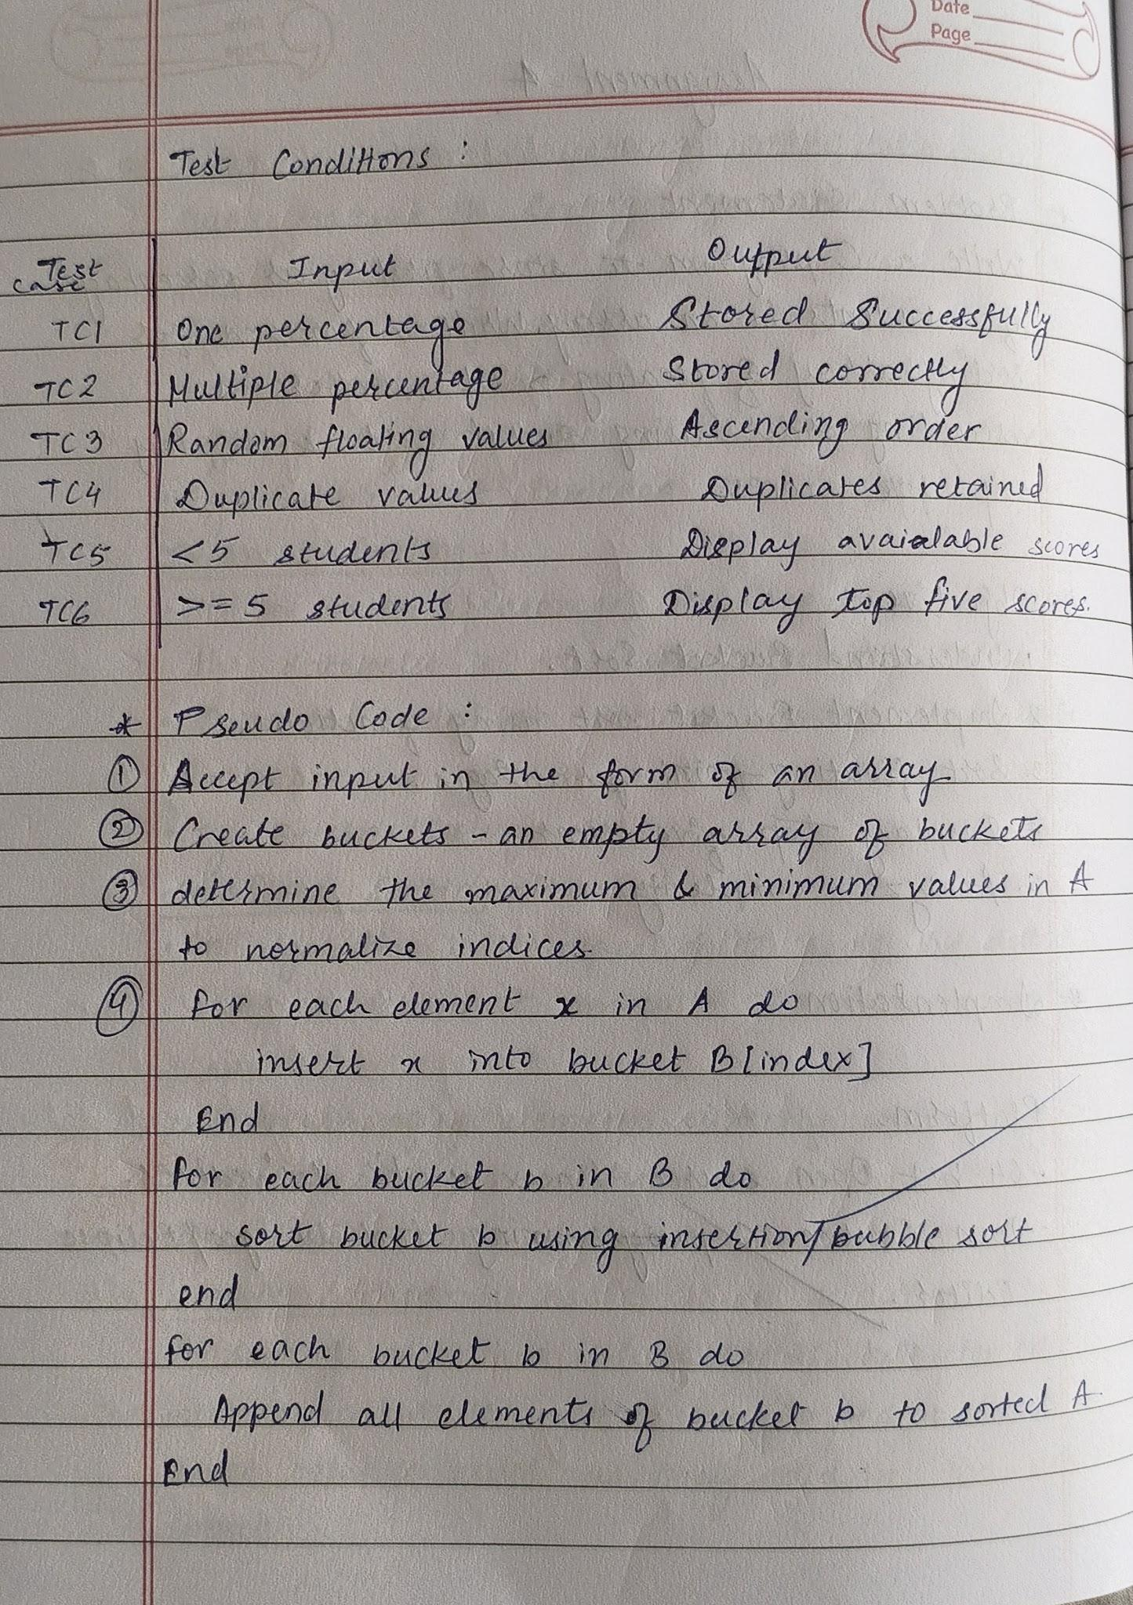
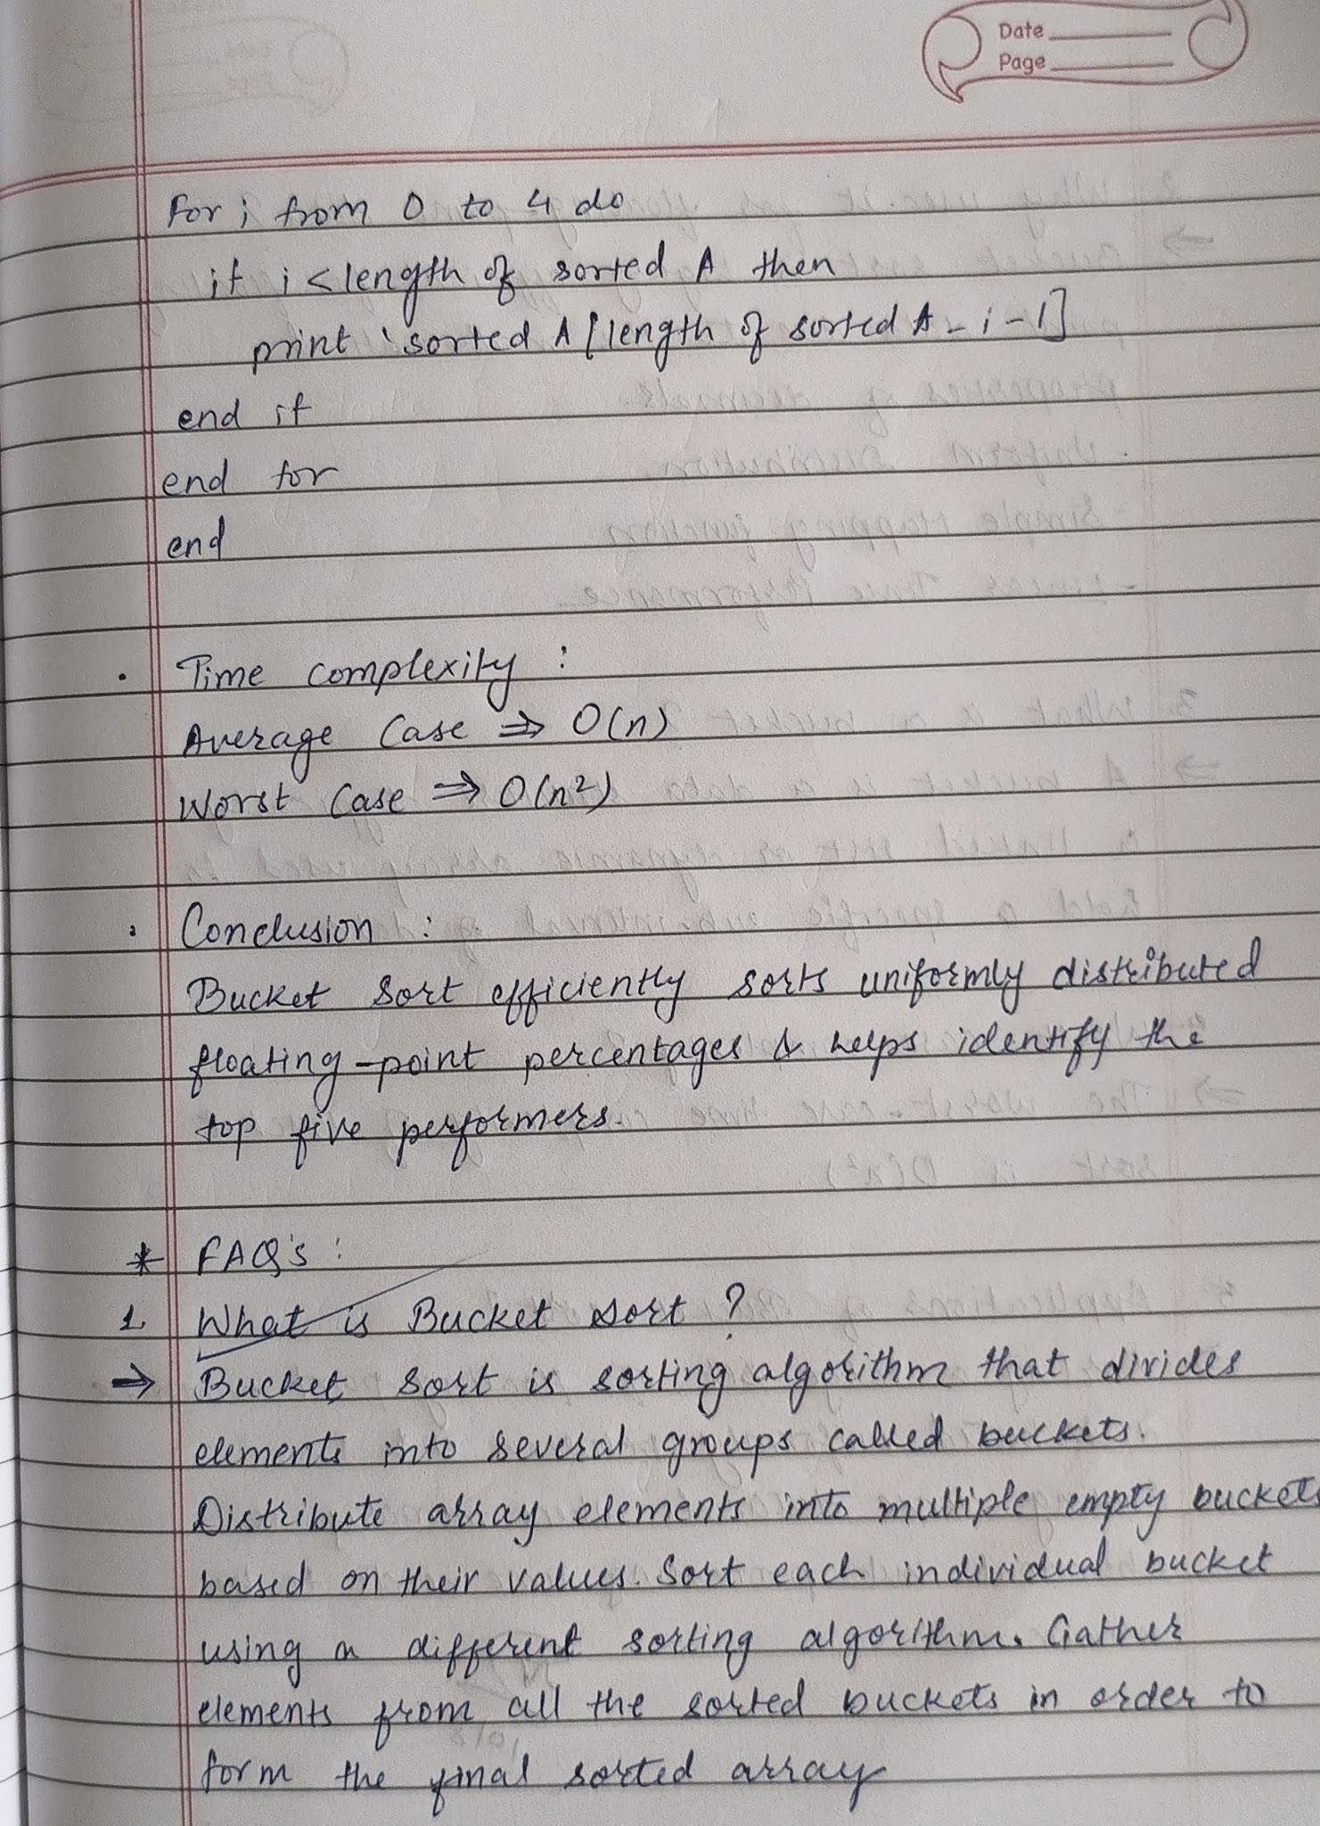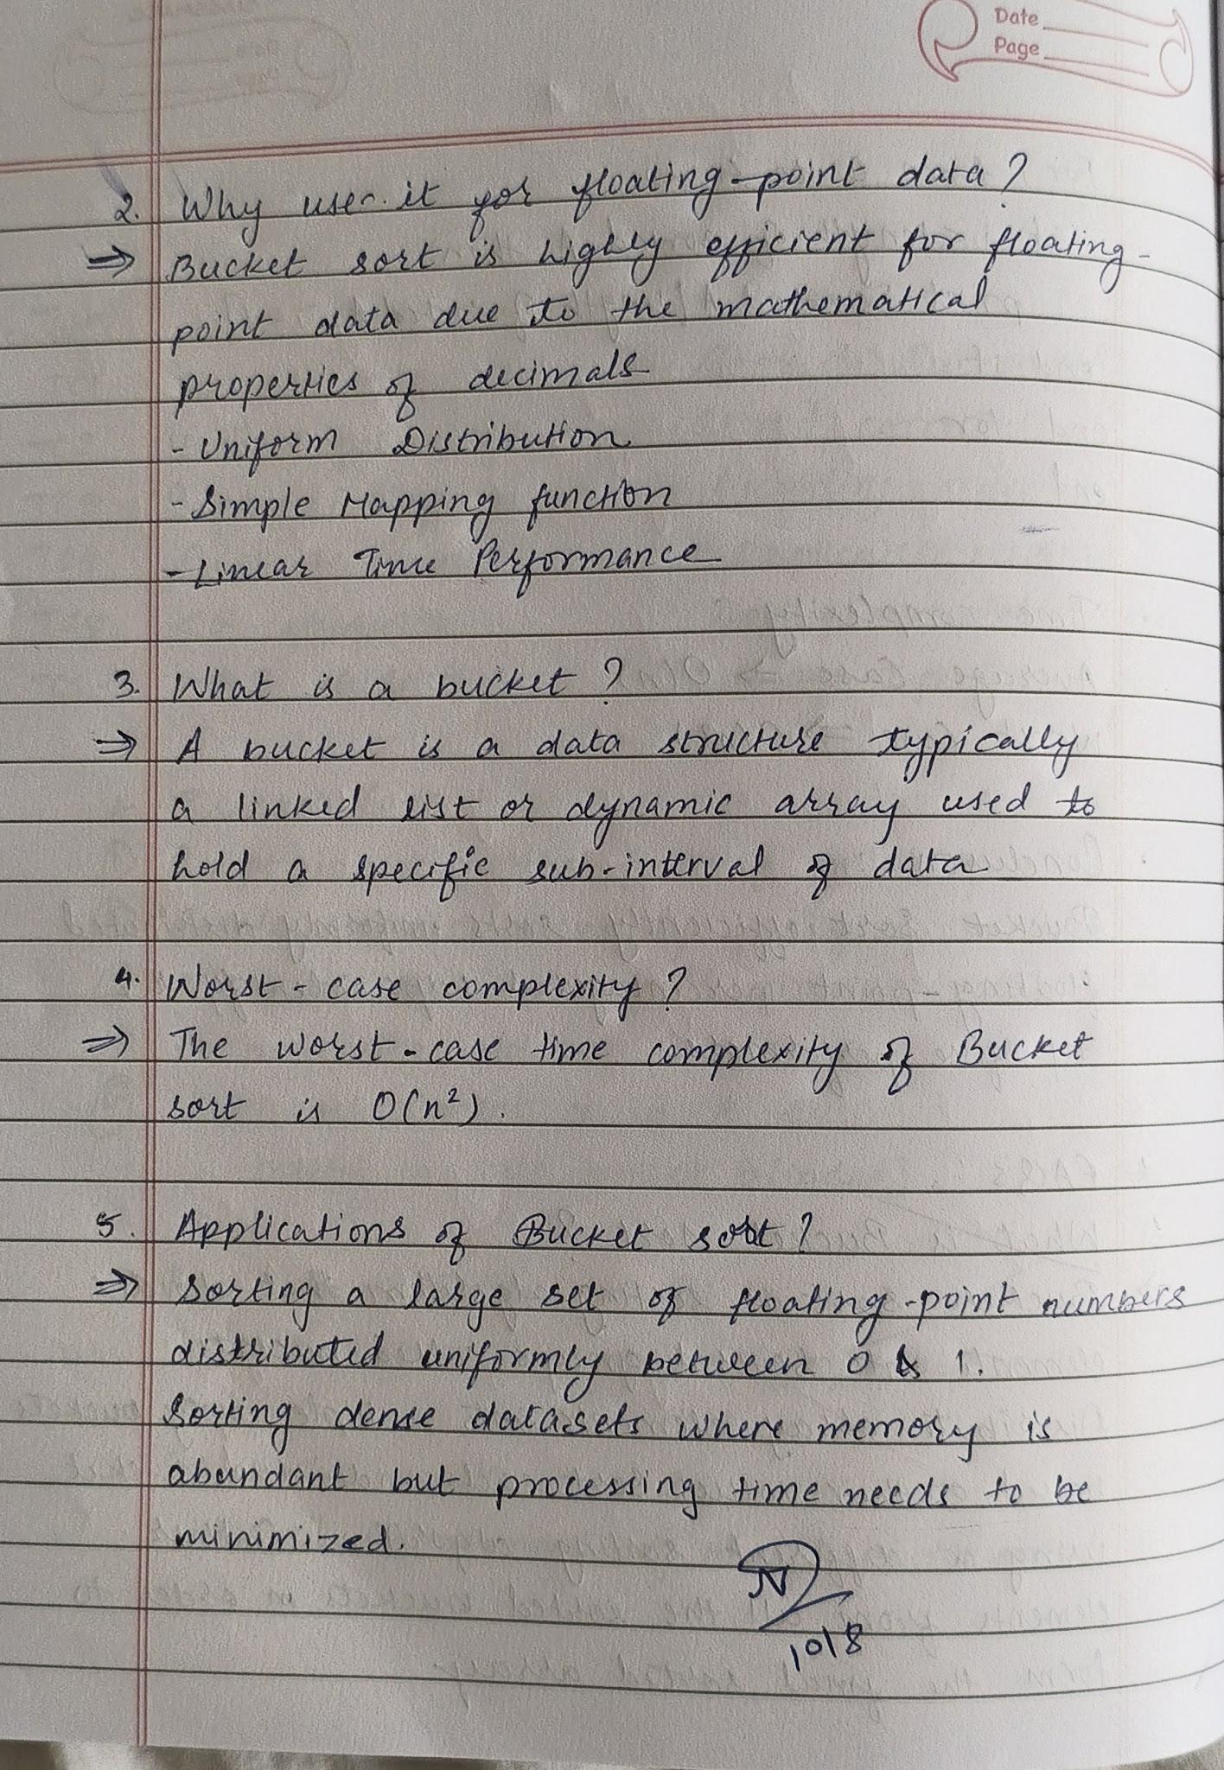

Code :
#include <stdio.h>

void bucketSort(float arr[], int n)
{
int i, j, k;
float buckets[101][100];
int count[101] = {0};

// Put elements into buckets according to integer part
for (i = 0; i < n; i++)
{
int index = (int)arr[i];
buckets[index][count[index]++] = arr[i];
}

// Sort each bucket using insertion sort
for (i = 0; i <= 100; i++)
{
for (j = 1; j < count[i]; j++)
{
float temp = buckets[i][j];
k = j - 1;

while (k >= 0 && buckets[i][k] > temp)
{
buckets[i][k + 1] = buckets[i][k];
k--;
}

buckets[i][k + 1] = temp;
}
}

// Merge all buckets back into array
k = 0;
for (i = 0; i <= 100; i++)
{
for (j = 0; j < count[i]; j++)
{
arr[k++] = buckets[i][j];
}
}
}

int main()
{
int n, i;

printf("Enter number of students: ");
scanf("%d", &n);

float percentage[n];

printf("Enter percentage of %d students:\n", n);
for (i = 0; i < n; i++)
{
scanf("%f", &percentage[i]);
}

bucketSort(percentage, n);

printf("\nPercentages in ascending order:\n");
for (i = 0; i < n; i++)
{
printf("%.2f ", percentage[i]);
}

printf("\n\nTop five percentages:\n");

int start = (n >= 5) ? n - 5 : 0;

for (i = n - 1; i >= start; i--)
{
printf("%.2f\n", percentage[i]);
}

return 0;
}

Output :
